**Universidad De las Fuerzas Armadas ESPE**

**OOP**

**Homework 07 User Requirements**

**Team 1: A-Byte Wizards**

1. **FRANK ALVARADO GREFA**
2. **MARIO SANTIAGO ANRRANGO BENAVIDES**
3. **KLEINER ALEXIS ARMAS GOMEZ**
4. **ALFONSO ALEJANDRO ARROYO PAREDES**

[**https://youtu.be/dvShyReit_U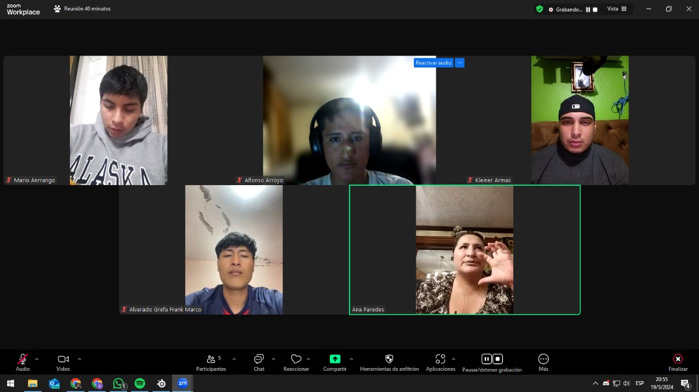**](https://youtu.be/dvShyReit_U)

**INTERVIEW FOR BASIC SYSTEM REQUIREMENTS**

**Registration and Management of Objects:** The software must allow the registration and efficient management of objects in stock and those used in the craft store.

**Products Sold:** The system must be able to handle craft products, especially related to FOMIX.

**Current Inventory Control:** A solution is needed to replace current manual inventory control methods, which include manual records in notebooks and periodic Excel tables.

**Custom User Interface:** A user interface that reflects the identity of the store is required, using colors related to the brand (range of purples), as well as graphic elements such as stars, astronauts, spaceships and planets.

**Management of Product Categories and Attributes:** The system must allow the classification of products by categories and attributes, such as sizes and thicknesses, especially for FOMIX products.

**Low Inventory Alerts:** A function is needed that alerts the user when products are about to run out or reach a minimum stock level (2 or 3 units, for example).

**Sales Functionalities:** The system must record sales, calculate the total of the sale, record the change returned to the customer, apply discounts and offers, and allow the sale of products with a price of zero.

**User Roles and Permissions:** Different user roles are needed, such as administrator (with full access), salespeople (with limited access to sales) and other customizable roles.

**Communication and Updates:** The development team is expected to maintain constant communication with the client and provide updates on the progress of the project.

In conclusion, these are the main requirements that could be extracted from the interview for the development of inventory management software for the craft store.

**Team 2: Overnight Developers Squad / Airline Reservation System**

1. **JULIO CESAR BLACIO MACHUCA**
2. **MIGUEL ANGEL CAIZA OÑA**
3. **KERLLY ALEXANDRA CHIRIBOGA CABRERA**
4. **JOFFRE ESTEBAN GÓMEZ QUINALUISA**

<https://www.youtube.com/watch?v=YDsDO2XIQT4>



**Main requirements (for the moment):**

* First, the system must mainly have a departure and an arrival date, and ask for the number of people that are traveling. This is for making the booking.
* Second, the system must include different methods of payment such as Credit or Debit Card, Paypal, etc.
* As well, the system must have the option of sending the ticket to the users personal email. Moreover, let the user view his ticket history.
* In addition, the system must allow the user to add more baggage at will, such as carry-on baggage or checked baggage.
* Also, the system must contemplate the offers that may appear during certain seasons.
* Additionally, the system will let users with a high class ticket do changes of date in this last one.
* Besides that, the system will have extra functionalities such as: an e-ticket, status of the ticket and from where is the ticket origin and his destiny. The system will have an extra Q&A section for new users.
* Furthermore, the system will have two ticket classes (for the moment) such as: tourist and business.
* Finally, the system will let the user know in what aeroline they are traveling. (random assignment for now).

**Conclusions:**

The airline reservation system must be robust and flexible, capable of managing a variety of functions and requirements as mentioned in the interview. From managing seasonal and advance booking prices to administering refund policies and handling baggage, the system should ensure an efficient and transparent booking experience for users. Additionally, it must provide clear options for both direct and connecting flights, ensuring that passengers are well informed about any additional procedures required for certain destinations.

**Team #03: Jezhe Software Engineers association**

1. **RICARDO ANDRES LAINEZ SUAREZ**
2. **JERSON STIVEN LLUMIQUINGA MORENO**
3. **ZAITH ALEJANDRO MANANGON VINUEZA**
4. **HEIDY SOLANGE MERA ROSERO**

[**https://www.youtube.com/watch?v=5WS-kGwtLZw&ab_channel=JEZHESoftwareEngineersAssociation**](https://www.youtube.com/watch?v=5WS-kGwtLZw&ab_channel=JEZHESoftwareEngineersAssociation)



**main requirements (for the moment):**

1. The system should handle up to 10 points in total for each partial, each assignment, test, exam and grade project should be measured by percentages.
2. The system should not bounce the system at the time of putting a grade, an example would be if a student has a 7.40 and in the system after a few days has 7.10, avoid this.
3. That the entry of the program is governed by a username and password, only the teacher is allowed to enter this so it is only a page for teachers.
4. When the partial is finished, the system should send a report about the student's grade.
5. That the transfer of grades is efficient.
6. To be able to add, delete, and edit the data, or grades of a student.
7. The student capacity will be between 20 to 30 students.
8. Grades will range from 0 to 10.

**Conclusions:**

By satisfying these requirements, the grade recording software will provide teachers with an efficient and secure tool for academic management, improving the accuracy of grade recording and facilitating the management of student performance. This will not only optimize teachers' time and effort, but will also contribute significantly to the educational quality of the institution.

**Team 4: [ CodeCrafting Engineers]**

1. **GABRIEL ANTHONY MOLINA GALLEGOS**
2. **LEYDI ESPERANZA OÑA SUQUILLO**
3. **MARCO ADRIAN PADILLA TRIVIÑO**
4. **DAVID ALEXANDER PILAGUANO CHISAGUANO**

**Link:** <https://youtu.be/uykaysUmZEE?si=HZNSTpS617KPxXcK>

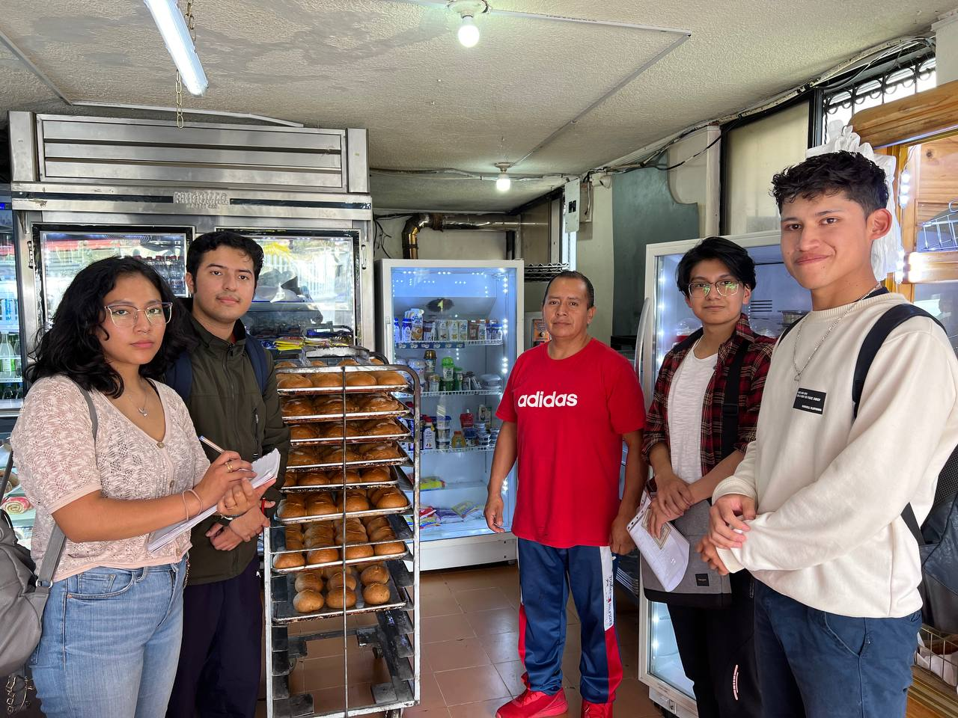

**Main Requirements for the Software:**

**Inventory Management:**

* It must generate alerts when stock levels are low and suggest reorder quantities.

**Cash Register Integration:**

* It must provide daily, weekly, and monthly sales reports for financial tracking.

**Product Management:**

* It must allow easy updates to product lists, prices, and descriptions.

**Order and Sales Processing:**

* It must record detailed sales information, including customer data, order contents, and payment status.

**Reports and Analysis:**

* The system must generate various reports, including sales trends, inventory usage, and customer behavior analysis.

**User Access and Security:**

* The system must have user authentication and role-based access control to ensure security.

**Support and Assistance:**

* It must have an option to contact support for troubleshooting and assistance.

**Conclusion:**

The management software for the bakery must be comprehensive and flexible, covering critical functions such as inventory management with stock alerts, detailed financial reports, easy product updates, detailed sales records, analytical report generation, security through access control and authentication, and robust technical support. This approach will ensure efficient operations, better financial control, and an improved customer experience.

**TEAM 5 [Paradigm Pioneers Squad]**

1. **ANDREA KATHERINE RAURA NEGRETE**
2. **JEANCARLO JAVIER SANTI CRUZ**
3. **LEIDY LISBETH SARAGURO CHAVEZ**
4. **KENNED JHAIR SIGCHA PALMA**

<https://youtu.be/yFI-KULr2x4?si=LrXh9cseQuAA3SrG>



**Requirements:**

After all the information collected, these are the following functions and requirements:

**1.- Client registration:**

1.1 Customers can register by providing their personal information such as name, email address and phone number.

1.2 Customers should be allowed to update their personal information and reset their passwords if necessary.

**2.- Computer rental:**

2.1 Customers can select a computer available for rent.

2.2 There must be a record of the start and end of the rental time for each computer.

2.3 Rental rates based on time of use must be calculated and applied.

**3.- Reservations:**

3.1 Customers can reserve a computer in advance for a specific time.

3.2 The system must confirm the availability of the requested computer at the time of reservation.

**4.- Payment system:**

4.1 Pay for time spent on the computer.

**Conclusion:**

In conclusion, the outlined functions and requirements provide a comprehensive framework for the development of a computer rental system. The system should prioritize seamless customer registration, allowing users to easily sign up, update their information, and manage passwords.

For computer rental, the system must facilitate the selection of available computers, maintain accurate records of rental durations, and calculate rental fees based on usage time.

Reservations should be supported, enabling customers to book computers in advance, with the system verifying availability at the requested time.

Lastly, a robust payment system is essential, allowing users to conveniently pay for the time spent on the computer. Overall, these functions and requirements lay the groundwork for an efficient and user-friendly computer rental service.

**Team 6: Code Masters**

1. **YOSTIN ARIEL SISALEMA JIMENEZ**
2. **EDGAR DAMIAN TOSCANO CORO**

**23. ERICK ALEJANDRO TUFIÑO ORTIZ**

<https://www.youtube.com/watch?v=tvYQaz1lwjo>



**Main requirements for the software:**

**Payment processing:**

* The system securely and smoothly handles different payment methods, such as bank transfers, credit cards, checks, etc.

**Security:**

* Security is essential to protect financial transactions.

**Versatile payment options:**

* To provide flexibility to users, the system will offer a variety of payment options and allow integration with multiple payment gateways.

**Modeling employees and pay roles:**

* The system allows the creation and management of employee profiles,salary functions and other data related to salary administration.

**Transparency and precision:**

* The main objective of the system is to provide greater transparency and accuracy throughout the salary administration process.

**Compliance with labor and tax regulations:**

* The system is designed to comply with applicable labor and tax laws, ensuring that salary, tax and deduction calculations are correct.

**Intuitive user interface:**

* A user-friendly interface is essential so that users can navigate and use the system without difficulty.

**Conclusion:**  
In conclusion, a Payment Role Management System is essential to ensure efficiency and accuracy in the administration of the payment roles of a company's employees.By implementing a well-designed system, companies can improve employee satisfaction and comply with financial and tax regulations.